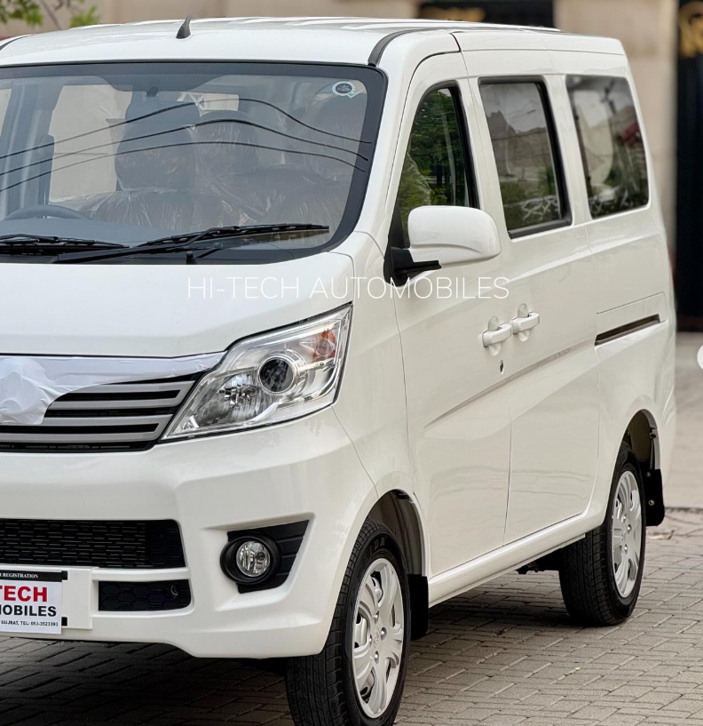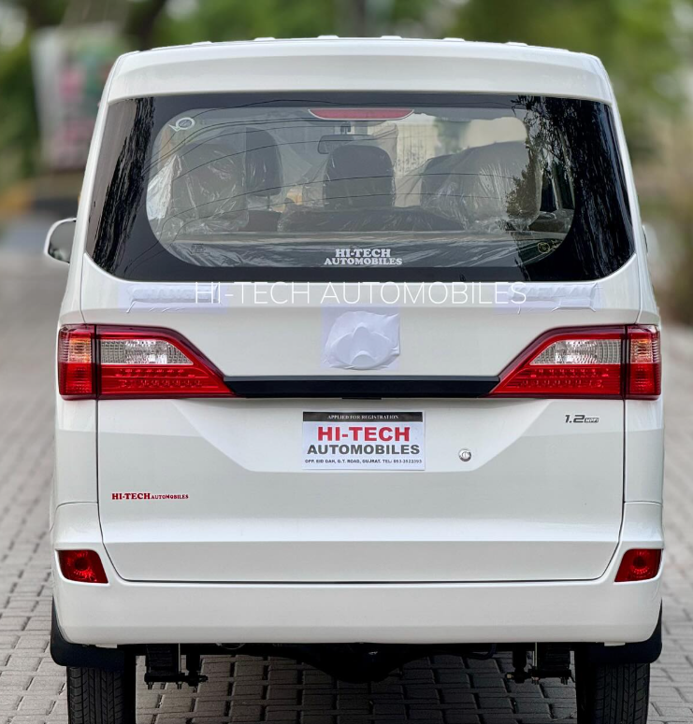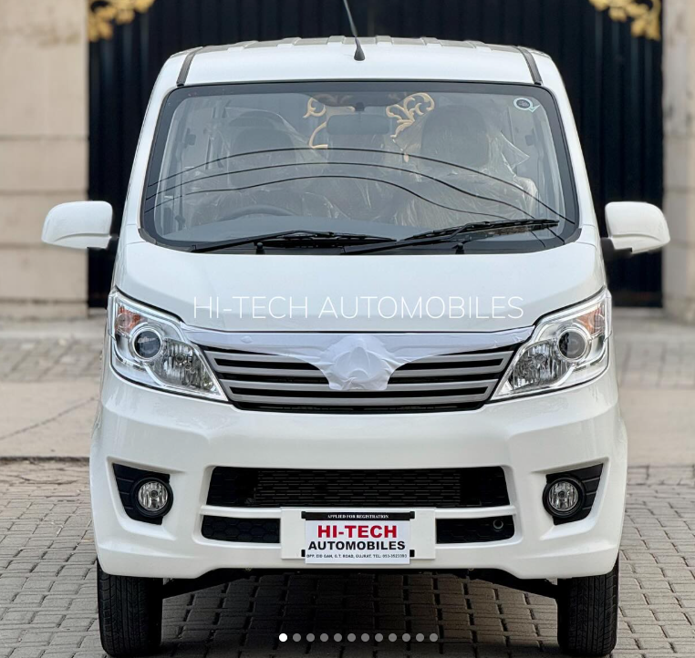

Main Specification of Changan Karvaan

**🚗 Powertrain & Performance**

* **Engine**: 999 cc or 1,243 cc inline‑4 MPI petrol, Euro‑IV
* **Power/Torque**:
  + 999 cc: 68 hp @ 6,000 rpm, 92 Nm @ 4,800 rpm
  + 1.2 L: 97 hp @ 5,000 rpm, 119 Nm @ 4,800 rpm
* **Transmission**: 5‑speed manual, front-wheel drive
* **Top Speed**: around 120 km/h (1.0 L), up to 180 km/h (1.2 L)

**📏 Dimensions & Capacities**

* **Length × Width × Height**: 3,980 × 1,620 × 1,890 mm
* **Wheelbase**: 2,560 mm
* **Ground Clearance**: ~165 mm
* **Kerb Weight**: approx. 1,140 kg
* **Seating**: standard 6 + 1 optional third‑row seat; many sources list 7‑seat capacity

**⛽ Fuel & Efficiency**

* **Fuel Tank**: 40 L
* **Mileage**: ~10 km/L city, ~12 km/L highway

**🛞 Wheels, Suspension & Brakes**

* **Wheels/Tires**: 14″ steel wheels, 165/70‑14 or 175/70‑14 tires on 1.2 L variant
* **Front Suspension**: MacPherson strut; **Rear**: leaf/tube‑shock or torsion‑beam
* **Brakes**: Front solid disc, rear drum; ABS standard

**🎯 Features & Comfort**

* **Steering**: Electric power steering
* **Notable Conveniences**: dual A/C vents, front power windows, keyless entry, central locking, projector headlamps (1.2 L)
* **Interior**: fabric seats, basic infotainment (AM/FM, USB/AUX), LCD instrument cluster (1.2 L)

**🛡️ Safety & Warranty**

* **Safety**: ABS, central locking, child lock, rear wiper; airbags not standard
* **Warranty**: 3 years or 60,000 km

**💰 Price (Pakistan)**

* **Karvaan Plus 1.2**: ~PKR 3.05 million (ex-factory)

**✅ Summary**

The Changan Karvaan is a budget-friendly, practical 7-seater MPV aimed at families and small business users. The newer 1.2 L variant delivers improved performance and features like dual A/C, projector lights, and keyless entry. It offers solid space and basic comfort, though it lacks airbags and advanced safety aids—a common trade-off at this price point in Pakistan.

Reddit users often describe it as:

“tons better than the Bolan… very fuel efficient and reliable”